**Checklist Epi API**

1. **Get list**

|  |  |
| --- | --- |
| Method | Endpoint |
| POST | /api-checklist/v1/epi/list |

|  |  |  |
| --- | --- | --- |
| Params | Data type | Description |
| Code_Prov_T | String | To filter any record under province |
| Code_OD_T | String | To filter any record under od |
| Code_Facility_T | string | To filter any record under hc |

|  |
| --- |
| Response as Json |
| [  {  "Rec_ID": 2,  "Code_Prov_T": "02",  "Code_OD_T": "0202"  "Code_Facility_T": "020214",  "VisitDate": "2021-06-10",  "CheckFrom": "2022-01",  "CheckTo": "2022-03",  "VisitorName": "Sok Kimleng",  "VisitorSex": "M" or "F",  "VisitorPosition": "Developer",  "VisitorPhone": "012917012",  "VisitorWorkplace": "CNM" or "PHD" or "OD",  "Part1Score": 100,  "Part2Score": 100  }  ] |

1. **Get detail**

|  |  |
| --- | --- |
| Method | Endpoint |
| POST | /api-checklist/v1/epi/detail |

|  |  |
| --- | --- |
| Params | Data type |
| Rec_ID | int |

|  |
| --- |
| Response as Json |
| {  "Rec_ID": 2,  "Code_Prov_T": "02",  "Code_OD_T": "0202",  "Code_Facility_T": "020214",  "VisitDate": "2021-06-10",  "CheckFrom": "2022-01",  "CheckTo": "2022-03",  "VisitorName": "Sok Kimleng",  "VisitorSex": "M",  "VisitorPosition": "Developer",  "VisitorPhone": "012917012",  "VisitorWorkplace": "CNM",  "Part1Score": 100,  "Part2Score": 100,  "MissionNo": "123ABC",  "Participants": [  {  "name": "តារ",  "position": "សិករ"  },  {  "name": "នារី",  "position": "កសិករ"  }  ],  "Detail": {  "Q1": { "Answer": {…}, "Score": 10 or null },  "Q2": { "Answer": {…}, "Score": 10 or null },  "Q3": { "Answer": {…}, "Score": 10 or null },  "Q4": { "Answer": {…}, "Score": 10 or null },  "Q5": { "Answer": {…}, "Score": 10 or null },  "Q6": { "Answer": {…}, "Score": 10 or null },  "Q7": { "Answer": {…}, "Score": 10 or null },  "Q8": { "Answer": {…}, "Score": 10 or null },  "Q9": { "Answer": "", "Score": 10 or null },  "Q10": { "Answer": "", "Score": 10 or null },  "P1Q1": { "Answer": {…}, "Score": 10 or null },  "P1Q2": { "Answer": {…}, "Score": 10 or null },  "P1Q3": { "Answer": {…}, "Score": 10 or null },  "P1Q4": { "Answer": {…}, "Score": 10 or null },  "P1Q5": { "Answer": {…}, "Score": 10 or null },  "P1Q6": { "Answer": {…}, "Score": 10 or null },  "P1Q6_1": { "Answer": "", "Score": 10 or null },  "P1Q7": { "Answer": {…}, "Score": 10 or null },  "P1Q7_1": { "Answer": "", "Score": 10 or null },  "P1Q8": { "Answer": {…}, "Score": 10 or null },  "P1Q9": { "Answer": {…}, "Score": 10 or null },  "P1Q10": { "Answer": {…}, "Score": 10 or null },  "P1Q11": { "Answer": {…}, "Score": 10 or null },  "P2Q1": { "Answer": {…}, "Score": 10 or null },  "P2Q2": { "Answer": {…}, "Score": 10 or null },  "P2Q3": { "Answer": {…}, "Score": 10 or null },  "P2Q4": { "Answer": {…}, "Score": 10 or null },  "P2Q5": { "Answer": {…}, "Score": 10 or null },  "Request": { "Answer": "", "Score": 10 or null },  }  } |

|  |  |  |
| --- | --- | --- |
| Multiple choices answer and Single choice answer | |  |
| Question | **Answer** | **Type** |
| P1Q3 | No internet, Phone/Tablet broken, Unknown usage, Other | Multiple |
| P1Q5 | No internet, Tablet broken, Unknown usage, Other | Multiple |
| P1Q8 | Far village, Not enough staff, Passing patient, No reports from VMW, Wait for OD, Other | Multiple |
| P1Q10 | Yes, No | Single |
| P1Q11 | Under 7 days, Over 7 days, Did not do | Single |
| P2Q1 | Under 14 days, Over 14 days, Did not do | Single |
| P2Q2 | Full, Not full, Did not fill | Single |
| P2Q3 | Draw, Did not draw | Single |
| P2Q4 | Done, Did not do | Single |

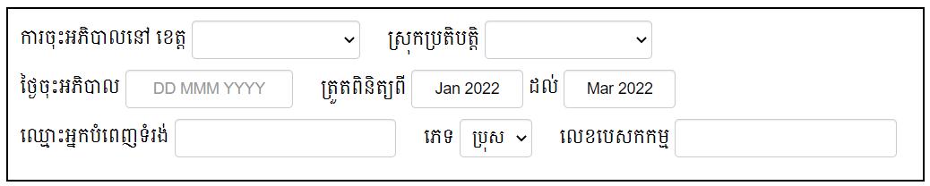

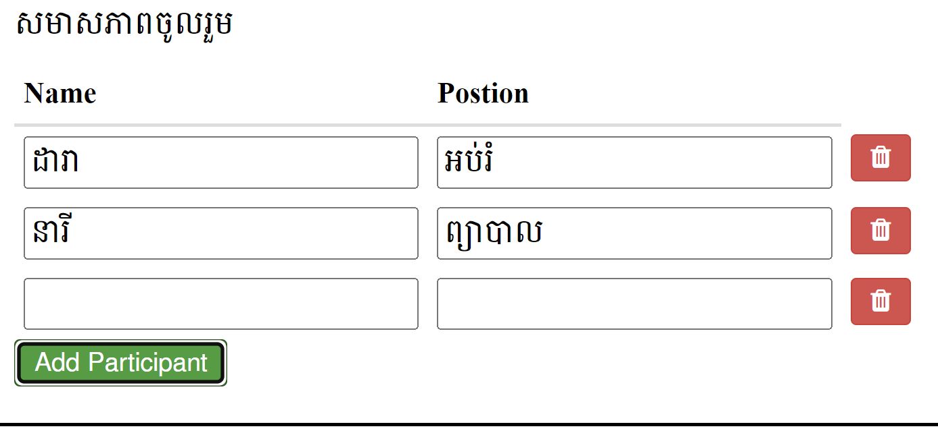

1. **Insert data & Update data**

|  |  |
| --- | --- |
| Method | Endpoint |
| POST | /api-checklist/v1/epi/update |

|  |
| --- |
| Object |
| {  "Rec_ID": 0 or 123, (0 for insert, number for update)  "Code_Facility_T": "020214",  "VisitDate": "2021-06-10",  "CheckFrom": "2022-01",  "CheckTo": "2022-03",  "VisitorName": "Sok Kimleng",  "VisitorSex": "M",  "VisitorPosition": "Developer",  "VisitorPhone": "012917012",  "VisitorWorkplace": "CNM",  "Part1Score": 100,  "Part2Score": 100,  "MissionNo": "123ABC",  "Participants": [  {  "name": "តារ",  "position": "សិករ"  },  {  "name": "នារី",  "position": "កសិករ"  }  ],  "Detail": {  "Q1": { "Answer": {…}, "Score": 10 or null },  "Q2": { "Answer": {…}, "Score": 10 or null },  "Q3": { "Answer": {…}, "Score": 10 or null },  "Q4": { "Answer": {…}, "Score": 10 or null },  "Q5": { "Answer": {…}, "Score": 10 or null },  "Q6": { "Answer": {…}, "Score": 10 or null },  "Q7": { "Answer": {…}, "Score": 10 or null },  "Q8": { "Answer": {…}, "Score": 10 or null },  "Q9": { "Answer": "", "Score": 10 or null },  "Q10": { "Answer": "", "Score": 10 or null },  "P1Q1": { "Answer": {…}, "Score": 10 or null },  "P1Q2": { "Answer": {…}, "Score": 10 or null },  "P1Q3": { "Answer": {…}, "Score": 10 or null },  "P1Q4": { "Answer": {…}, "Score": 10 or null },  "P1Q5": { "Answer": {…}, "Score": 10 or null },  "P1Q6": { "Answer": {…}, "Score": 10 or null },  "P1Q6_1": { "Answer": "", "Score": 10 or null },  "P1Q7": { "Answer": {…}, "Score": 10 or null },  "P1Q7_1": { "Answer": "", "Score": 10 or null },  "P1Q8": { "Answer": {…}, "Score": 10 or null },  "P1Q9": { "Answer": {…}, "Score": 10 or null },  "P1Q10": { "Answer": {…}, "Score": 10 or null },  "P1Q11": { "Answer": {…}, "Score": 10 or null },  "P2Q1": { "Answer": {…}, "Score": 10 or null },  "P2Q2": { "Answer": {…}, "Score": 10 or null },  "P2Q3": { "Answer": {…}, "Score": 10 or null },  "P2Q4": { "Answer": {…}, "Score": 10 or null },  "P2Q5": { "Answer": {…}, "Score": 10 or null },  "Request": { "Answer": "", "Score": 10 or null },  }  } |

|  |
| --- |
| Response as Json (Insert data only) |
| { "Rec_ID": 1 } |

1. **Delete data**

|  |  |
| --- | --- |
| Method | Endpoint |
| POST | /api-checklist/v1/epi/delete |

|  |  |
| --- | --- |
| Params | Data type |
| Rec_ID | int |